9511 Vallecito Mesa
San Antonio, TX 78250

210.507.5111
info@sachproductions.org
www.sachproductions.org
FOR IMMEDIATE RELEASE Media Contact

S A C H P R O D U C T I O N S
February 24, 2006 Manmeet Singh | 210.507.5111

The Widow Colony Premieres in Los Angeles

Los Angeles – Socio-political leaders, human rights activists, community leaders and civic organizations came together for the US premier of the film, “The Widow Colony – India’s Unsettled Settlement” on February 22, 2006 in Los Angeles. The film, directed by Harpreet Kaur, explores the continued suffering of victims of anti-Sikh pogroms in India. It records their battle for justice and struggle for survival.

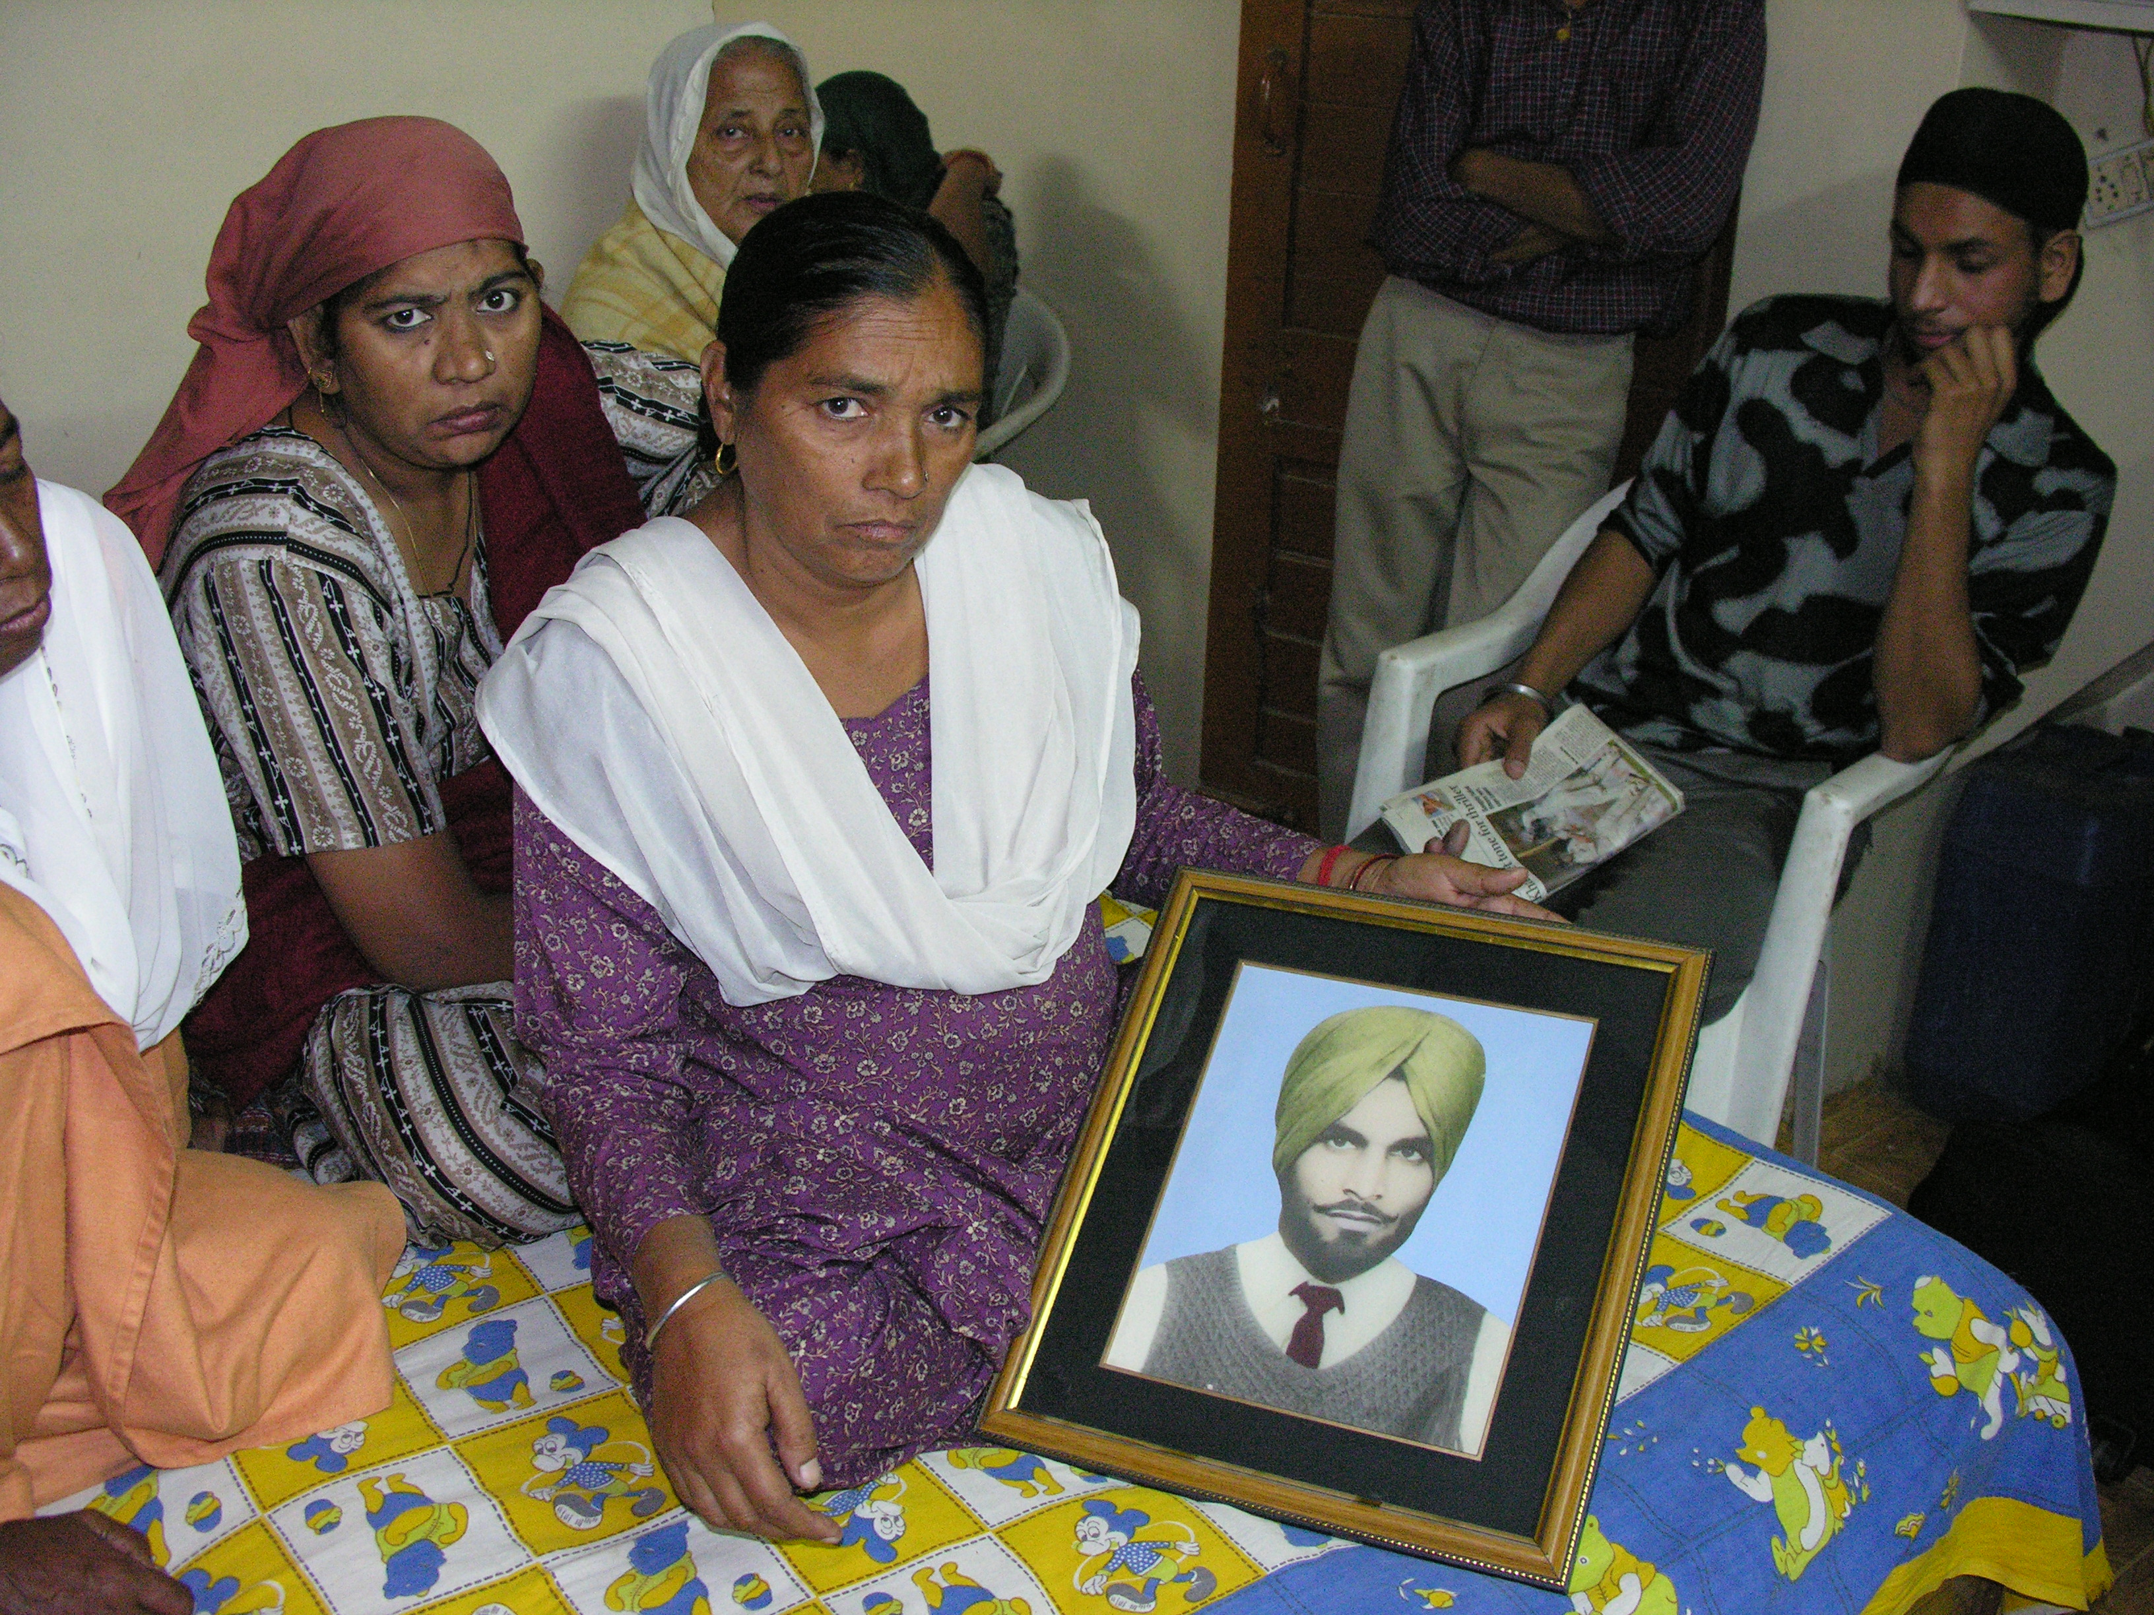
A moving and emotional depiction of the trauma that still haunts innumerable widows of the Sikh massacre, the film unearths the sad and deplorable condition of most of these widows living in the vidhva (widow) colonies of Delhi. Produced by Sach Productions, the film records the testimonies of victims, Sikh widows and men, who survived the bloodbath of November ’84. The context to the anti-Sikh violence is provided by the following subject experts: Justice Sachar, Harvinder Singh Phoolka, Kuldip Nayar, Patwant Singh, Madhu Kishwar, and Jaskaran Kaur. The film focuses on the incalculable loss of human life. Scores of widows were created in Delhi, most of who lived in colonies of Trilokpuri, Kalyanpuri, Himatpuri, Sultanpuri and Mongolpuri. A conservative estimate puts the total number dead around 4,000. And, if losing their loved ones was not enough, justice has been denied to these victims for over two decades. Rather, three accused were awarded with cabinet positions in the Indian government in May 2004 and recent apology by the Prime Minister fails to acknowledge the state responsibility.
A Widow from the Garhi Settlement in New Delhi shows a picture of her husband who was killed in November ‘84

The event hosted by SikhPoint.com also included the screening of ‘Nineteen Eighty Four' and the Via Dolorosa Project directed by the Singh Twins. A panel discussion was organized by the Sikh Research Institute (SikhRI) that followed both screenings. The panelists included social activist and acclaimed director of the film Amu, Shonali Bose; Co-founder and Executive Director of Ensaaf, Jaskaran Kaur; and author and Director of the Center for the Study of the Holocaust, Genocide, and Human Rights, Dr, John Roth. The panel provided insights on several critical issues: justice, documentation, rehabilitation, healing, memory, and activism, to name a few. The panel emphasized that this film will play a major educational role. Harinder Singh, Executive Director of SikhRI and panel moderator, concluded: “It is our personal and human responsibility to be directly concerned with oppression and injustice. We must resist it instead of remaining unconcerned, assuming others will intervene to destroy it. Let us not sit in the corner, or on the sidelines, telling ourselves that it is none of our concern or that it is the concern of God alone. Let’s work towards justice, rehabilitation, or anything that matters and counts!”

Harpreet Kaur, the director of The Widow Colony, shared her reflections and urged the audience to take part in the documentation and rehabilitation effort being spearheaded by SikhRI. The widows have been living in meager conditions for decades; unable to give proper care to their children, the widow colonies are filled with uneducated jobless youth consumed with injustice and trauma

The Widow Colony is a Sach Productions presentation with support from the Sikh Research Institute. Its
Harpreet Kaur, Director (left) and Manmeet Singh, Producer (right), address the audiences at the premiere

next screening is at the Indian Film Festival of Los Angeles (indianfilmfestival.org) in April.

For more information including Canadian and British premieres, please visit the website at www.TheWidowColony.com.

###

