9511 Vallecito Mesa
San Antonio, TX 78250

210.507.5111
info@sachproductions.org
www.sachproductions.org
FOR IMMEDIATE RELEASE 19 July 2006

S A C H P R O D U C T I O N S
Media Contact Manmeet Singh | 210.507.5111

The Widow Colony Wins Best Documentary Award in Toronto

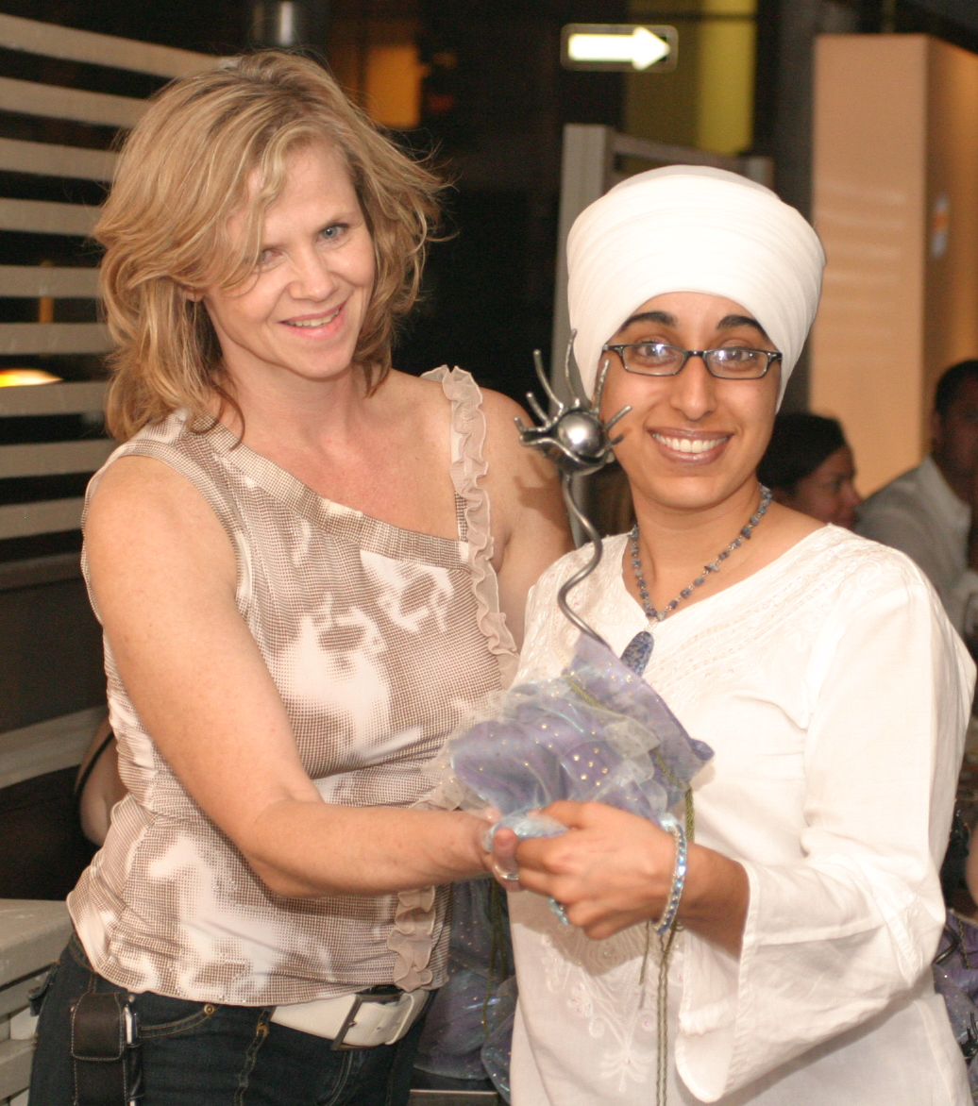
Harpreet Kaur’s documentary, The Widow Colony won the award for Best Documentary at the prestigious Female Eye Film Festival, held in Toronto. Upon receiving the award Kaur said, “This award proves that the interest for this documentary is not only in South Asian audiences and human rights organizations but it appeals to audiences all over the world.”
Harpreet Kaur, Director of The Widow Colony, receives the award from Leslie Ann Coles, the Director of the Female Eye Film Festival

Kaur’s film takes the viewers onto a journey into the living conditions of the surviving Sikh widows and children in New Delhi who have been struggling to sustain their families while maintaining their struggle for justice, 22 years after the murders of their men.

The film focuses on the incalculable loss of human life in the span of just three days. A conservative estimate puts the total number of Sikh men dead around 4,000, leaving behind over 1,300 widows and thousands of children fatherless. Despite all the evidence and eye witness testimonies justice has been denied to these victims for over two decades.

Described by critics as the “most affecting” documentary to come out of India since Born into Brothels, The Widow Colony is Kaur’s most poignant work that has been recognized and endorsed by prominent personalities like Soli Sorabjee, ex-Attorney General of India, Patwant Singh, India’s prominent author, human rights organizations etc. and is drawing audiences from all backgrounds.
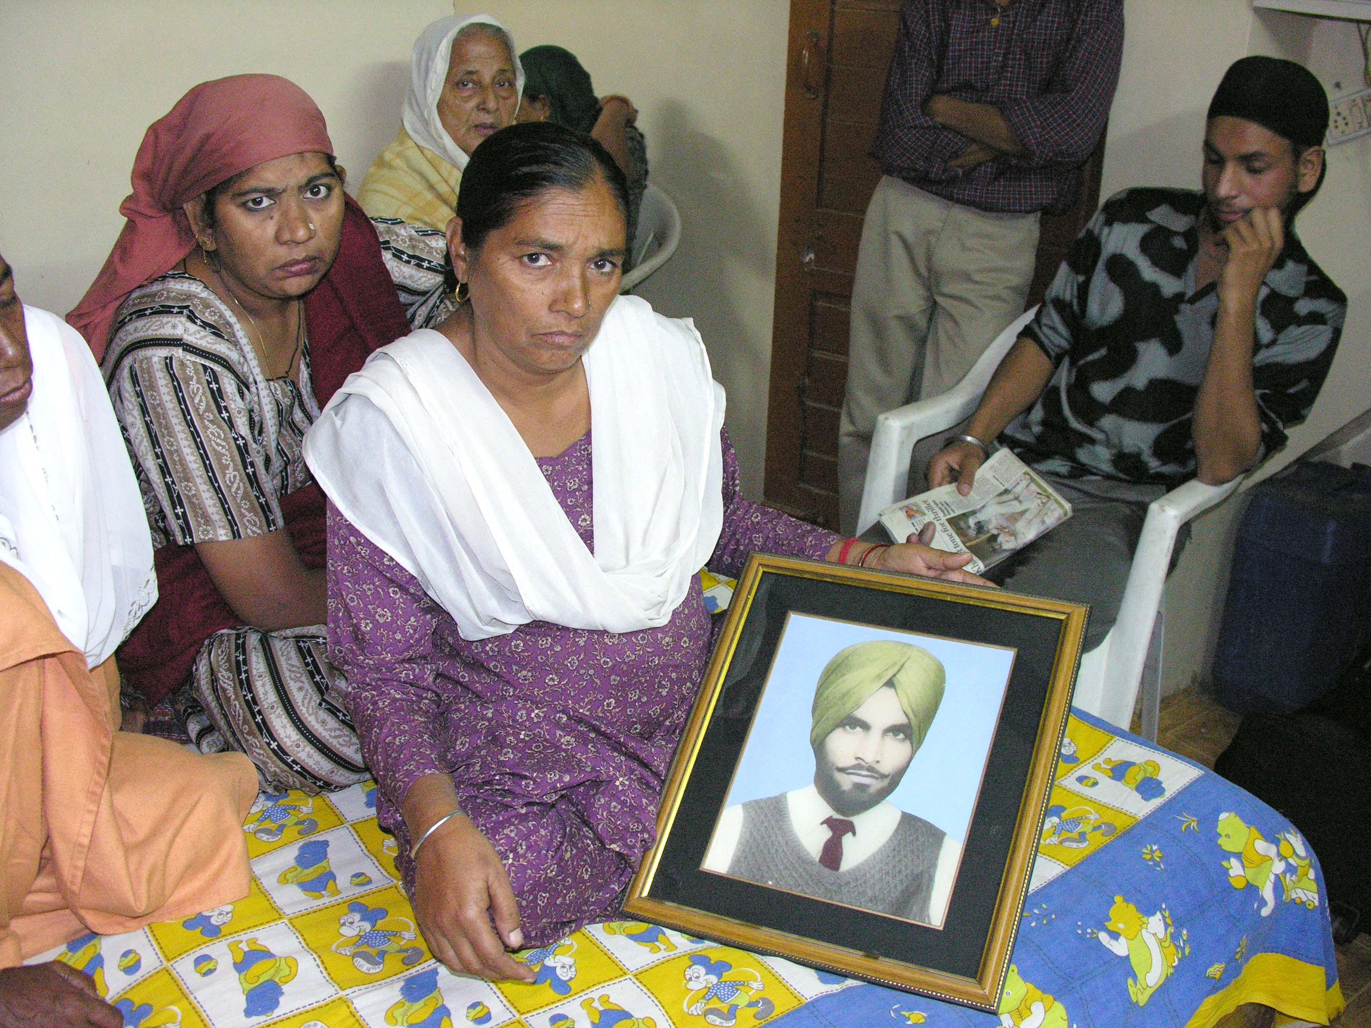
The Widow Colony has been produced by Sach Productions with the support of Sikh Research Institute and Kaur expressed her gratitude for all those who participated in the film. “I’m standing here and being honored because of the women, children and all the survivors in my documentary. I thank them dearly for sharing their stories with me and helping make this documentary possible.”

Kaur’s film has had the honor of touring various film festivals. Previously it was nominated for best documentary at the prestigious Indian Film Festival of Los Angeles where it shared the same platform with Deepa Mehta’s Water, and Rahul Dholakia’s Parzania, starring Naseeruddin Shah. The movie brings new revelations on the massacre that occurred 22 years ago and its universal approach is certain to appeal to all audiences but is a must see for those concerned with South Asian, religious, human rights and women issues.
###

